Honeoye Valley Association
Meeting Minutes
6:30pm April 16, 2018
Held at the Honeoye Library
Board Members  Dan Lalonde President, Webmaster  Jerry Passer  Terry Gronwall  Dorothy Gronwall  Dave Baker Treasurer  Elaine Cook  Don Cook  Caroline Sauers Grapevine, Secretary  Tim Mc Auliffe  Len Wildman  Lindsay McMillan  Ken Klump | Present  Present  Present  Present  Present  Present  Present  Present  Absent  Present  Present  Absent | Guests
Approval of the Minutes
LW Motion to approve the minutes, JP second, Ayes unanimous.
DAN OUT OF TOWN MAY 1 TO 17TH

Treasurer Report
Find Attached, Treasurer Report from Dave Baker.
DC motioned to accept the treasurers report TG second, Ayes unanimous.

In the HVA Membership system, we are now letting everyone know that their membership is up for renewal 30 days before each membership expires.

Roadside Clean Up
HVA board meeting at the American Legion around 8:30. We should have bags via Dan.
Caroline will collect the signs and get them to Jerry when he returns,
CS will get a look at how Bill handles it all on Saturday.
Inmates and bags on 20-A.

Photo Contest
Live Voting on the First Second and Third prizes at the annual meeting.
CS to send the Press Release emails for the Photo contest to LM, PO Box 165.
Annual meeting July 14th.

Water Craft Steward Program
Should we revisit the Lake Friendly Living Guide.
Finger Lakes Institute confirmed for Sept and Oct. they will do the best they can for May.

Neighborhood Outreach Group

HVA Proposal to Involve More HVA Members and Lake Residents CSLAP
TG hand out a HAB Surveillance program. Residents to report on their beach, neighborhood and or any where else designated. This would expand our monitoring. 10 Miles of Shoreline.
Increase community engagement, goodwill may expand knowledge base.
Secchi Disk Program mirroring Canandaigua Lake data. The goal is to expand monitoring and community involvement. Promote as a membership initiative monitoring program.
TG to work with LM to put together some instructional videos.
TG work towards a map with the sightings, HAB’s change quickly this may not be a good idea.
DB motion to fund up to $750.00 to move the HAB monitoring program forward, LM second with checking into the insurance as an indicator.

Symposium
Scheduled for June 9th. TG share where we are on the HAB program. BL macrophyte and pick up barge and harvester. TG on CSLAP. LM look into the Education program from Canandaigua Lake Open at 9am for the tables with Presentation 10 to 11:30.

Governor’s HAB
Mixed views on how to deal with phosphorus from the legacy nutrients. (alum and aeration.)
Mitigate the internal load.

TG motion to adjourn LW second, Ayes unanimous

Next Meeting May 21, 2018 6:30 – 8PM Location Richmond Library

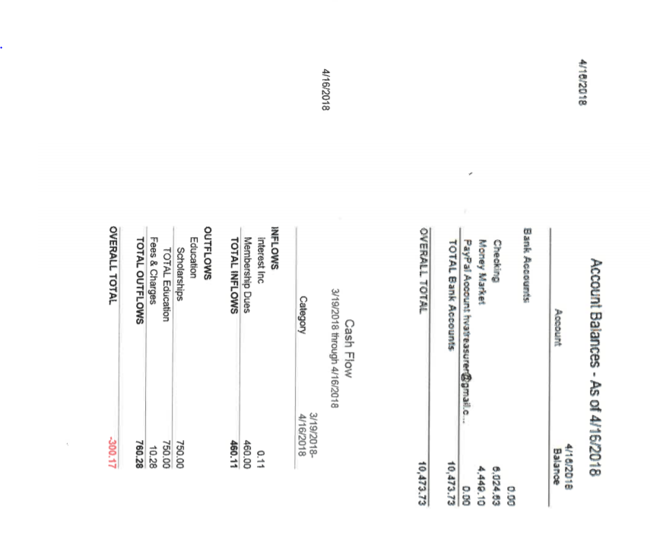

Tabled for future meeting, Board Members Please Consider Championing something on the list you are interested in.

Review of HVA Mission and projects review – All Time left
-projects – duck race, canoe race
- town effort to protect beach area with boom or some device(s)
- Increase emphasis on HAB mitigation, elimination, minimization, etc – algaecides? Tie in with TMDL results and potential solutions
- Major Stream vernal pools or solution to slow water.
- Fund study to update macrophyte study? Address harvester and possible herbicides
2nd pass at planning meeting ( Use regular meeting time) – ALL
- Ranked items from each board member

* Committees
- membership
- letter writing
-personal reach out
- revised emails
- automatic renewals
- lake associations
- community projects
Yard Waste
Food Drive
Boat Launch monitor
Co Sponsor Pirate Festival
Start a parade of Boats event with prizes
Develop a lake safety/good lake user brochure to hand out to boat renters and boat launch visitors
New sign about lake rules at Trident Marina
Sandy Bottom Nature Display/Sigange/garden
- communications
- symposium
- newsletter, email blasts
- newspapers
- website refresh
- Grapevine
- Educational Outreach
- Lake Living Guide
- School program
- Boat safety, lake use guidelines , handouts at Marine, boat launch
-How to renew emphasis on Macrophyte Study and publishing results
- New sign about lake rules at Trident Marina
* Charitable contributions to community efforts
FLCC scholarship
Town beach bubblers?

Communications
• -Grapevine – Caroline Shore line plantings
• -Facebook Page - Carole

Lake Quality/HLWTF
- Richmond Honeoye Lake Maintenance Committee - NEW???

